RFQ PROCESS FLOW
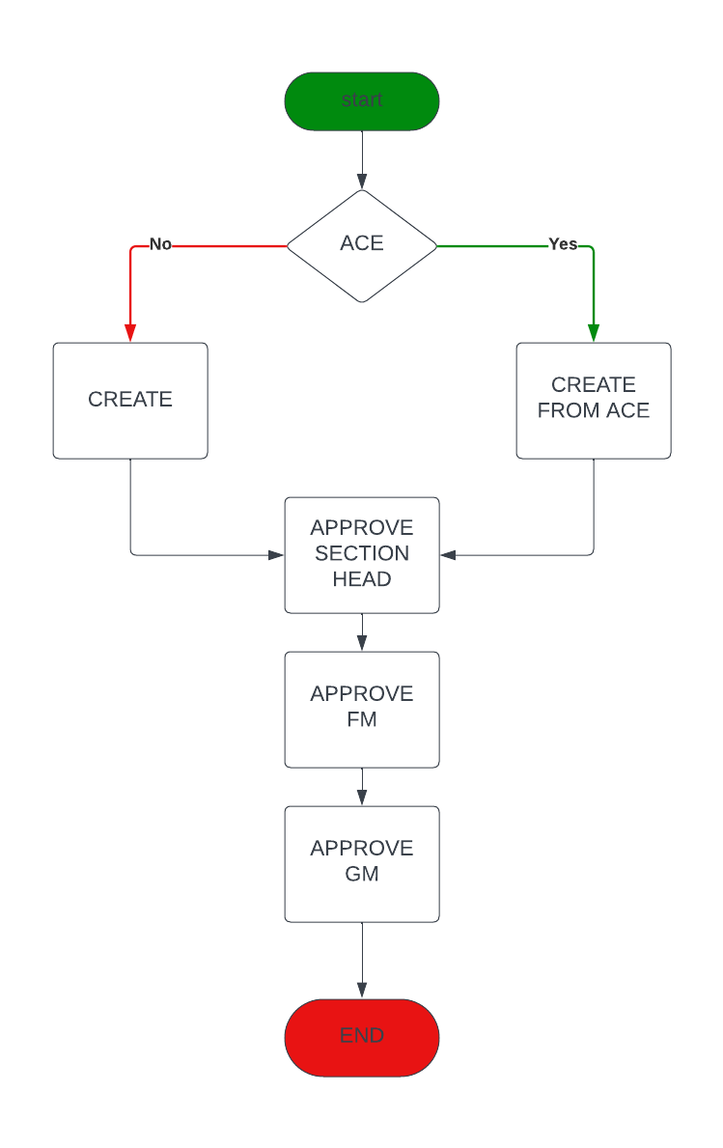

Tasks
- Create from ACE Ashley
- Create RFQ Perseverance
- Approve RFQ Ashley and Danai
- View RFQs Ruvheneko
- RFQ Reports/ filtering Tatenda

RFQ Model
- Date created
- Date approved
- Approved by
- Qoutations
- RFQ Number
- ACE Number
- RFQ section, region/ section/depot/district/cost centre
- Section

